Moreno, Melissa

February 17, 2019

Sur5386, Tutorial 3

**Part 1: Atmospheric Correction using FLAASH in ENVI**

1.3 and 1.4 - Load and display remote sensing image/ FLAASH Atmospheric Correction

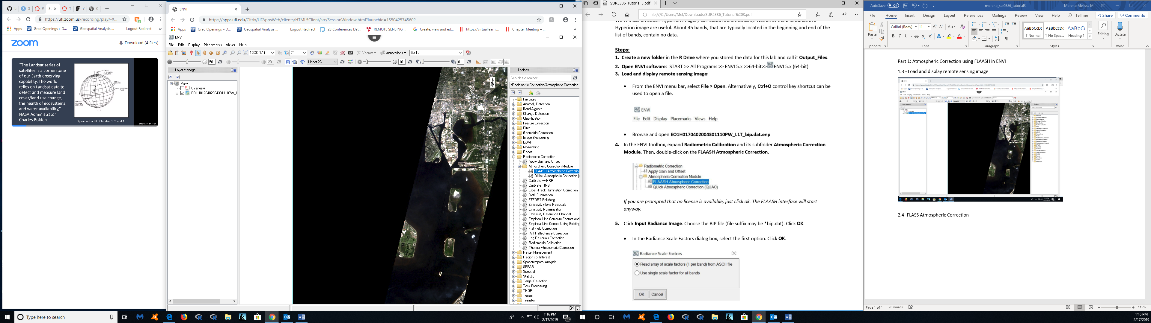

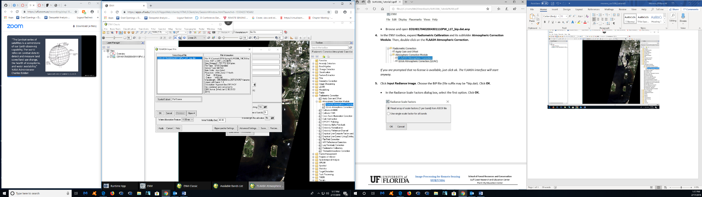1.5 Input Range Image

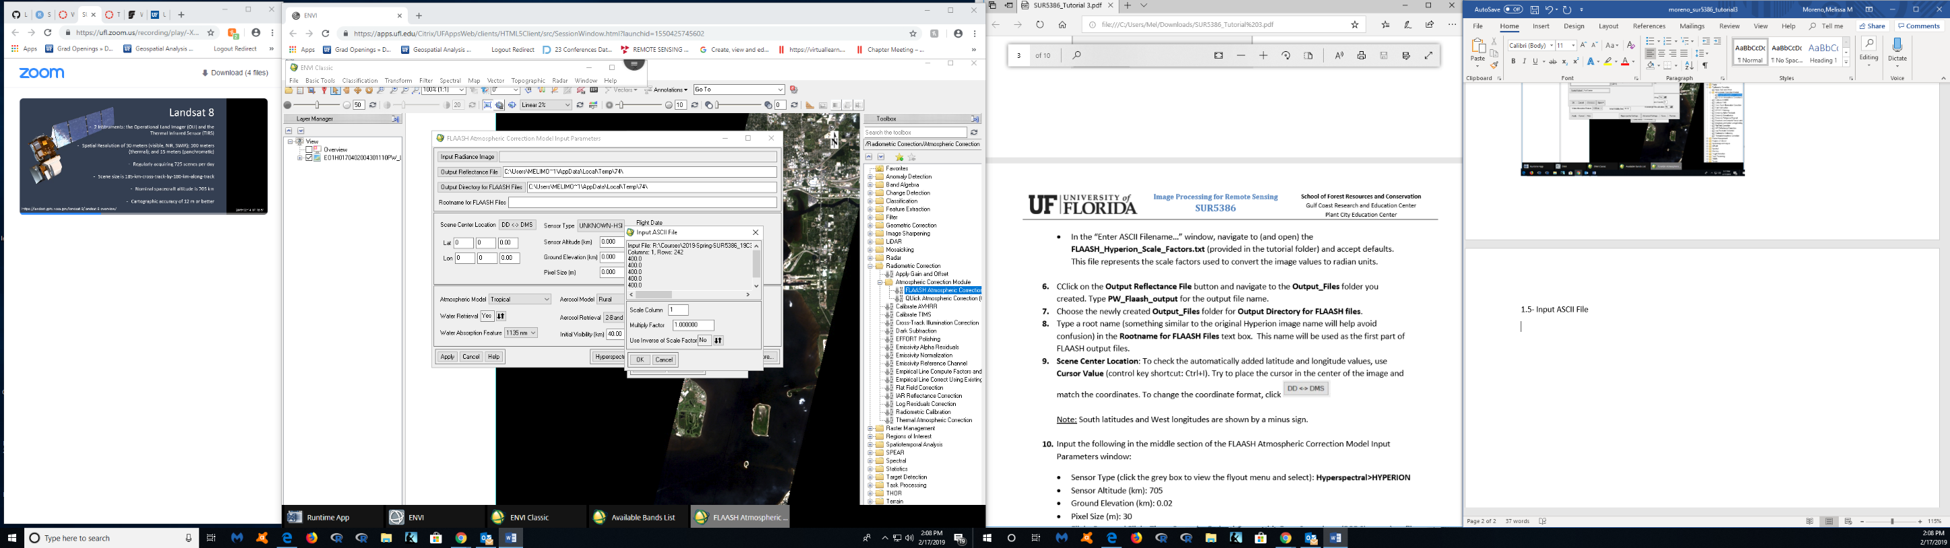1.5- Input ASCII File

1.6 to 1.8- Output_files

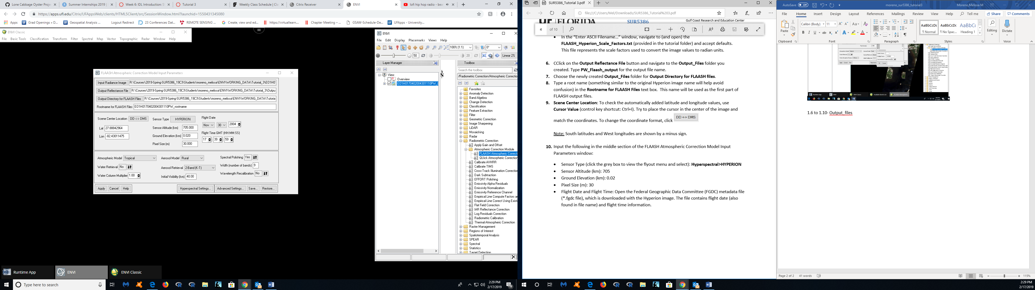

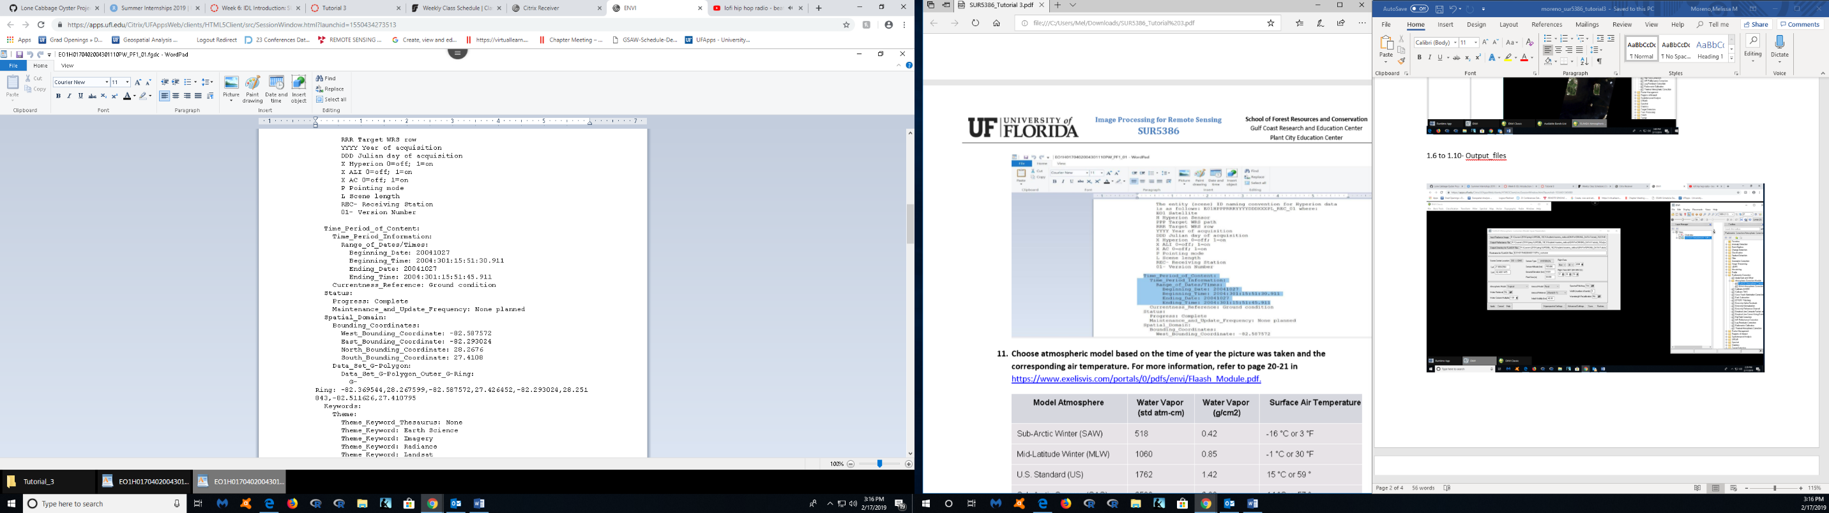1.10

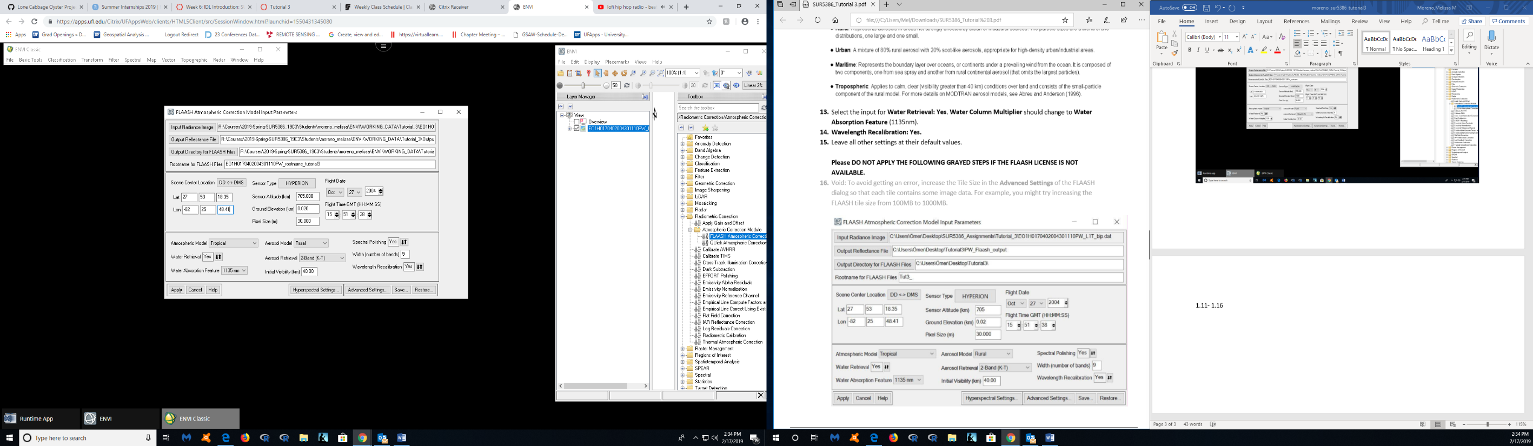1.11- 1.16

1.19

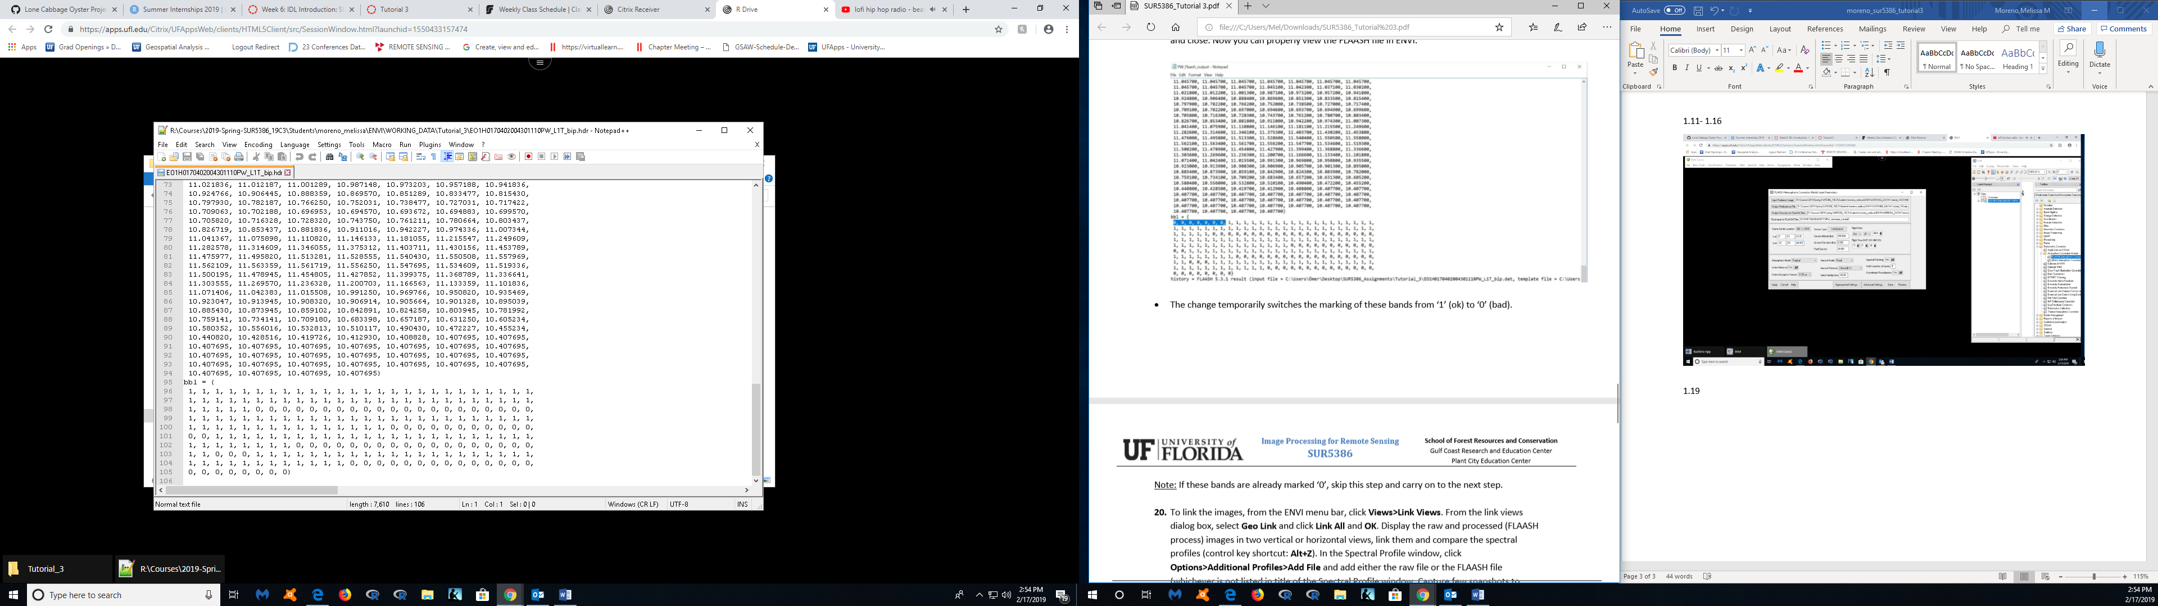

1.20 – Linking views

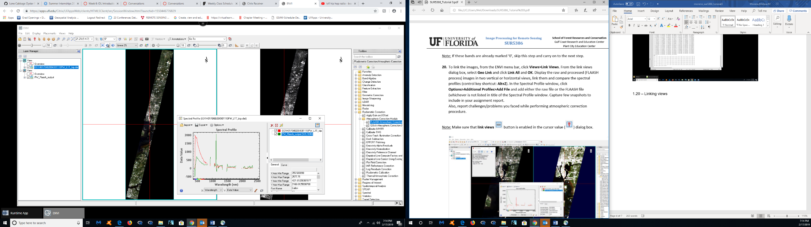

**Part 2: Create spatial subset**

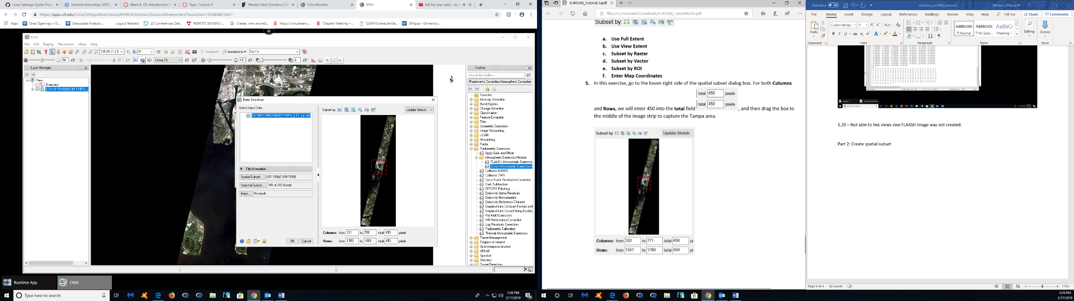2.5 - Spatial Subset

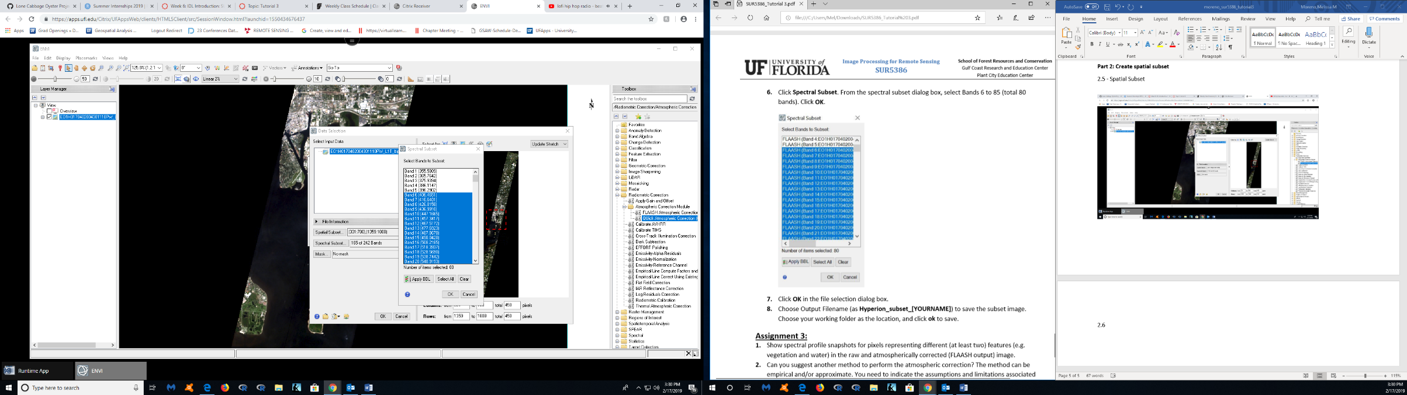2.6

**Assignment 3:**

1. Show spectral profile snapshots for pixels representing different (at least two) features (e.g. vegetation and water) in the raw and atmospherically corrected (FLAASH output) image.

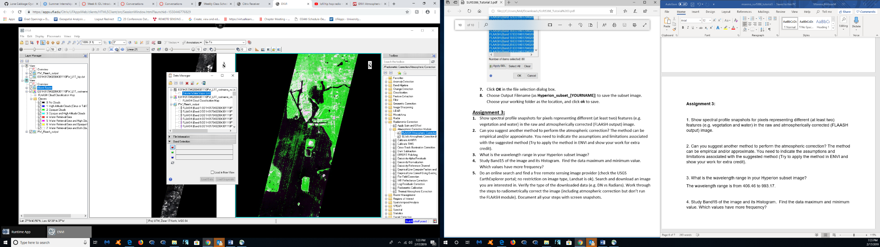Column Water Vapor (cm)

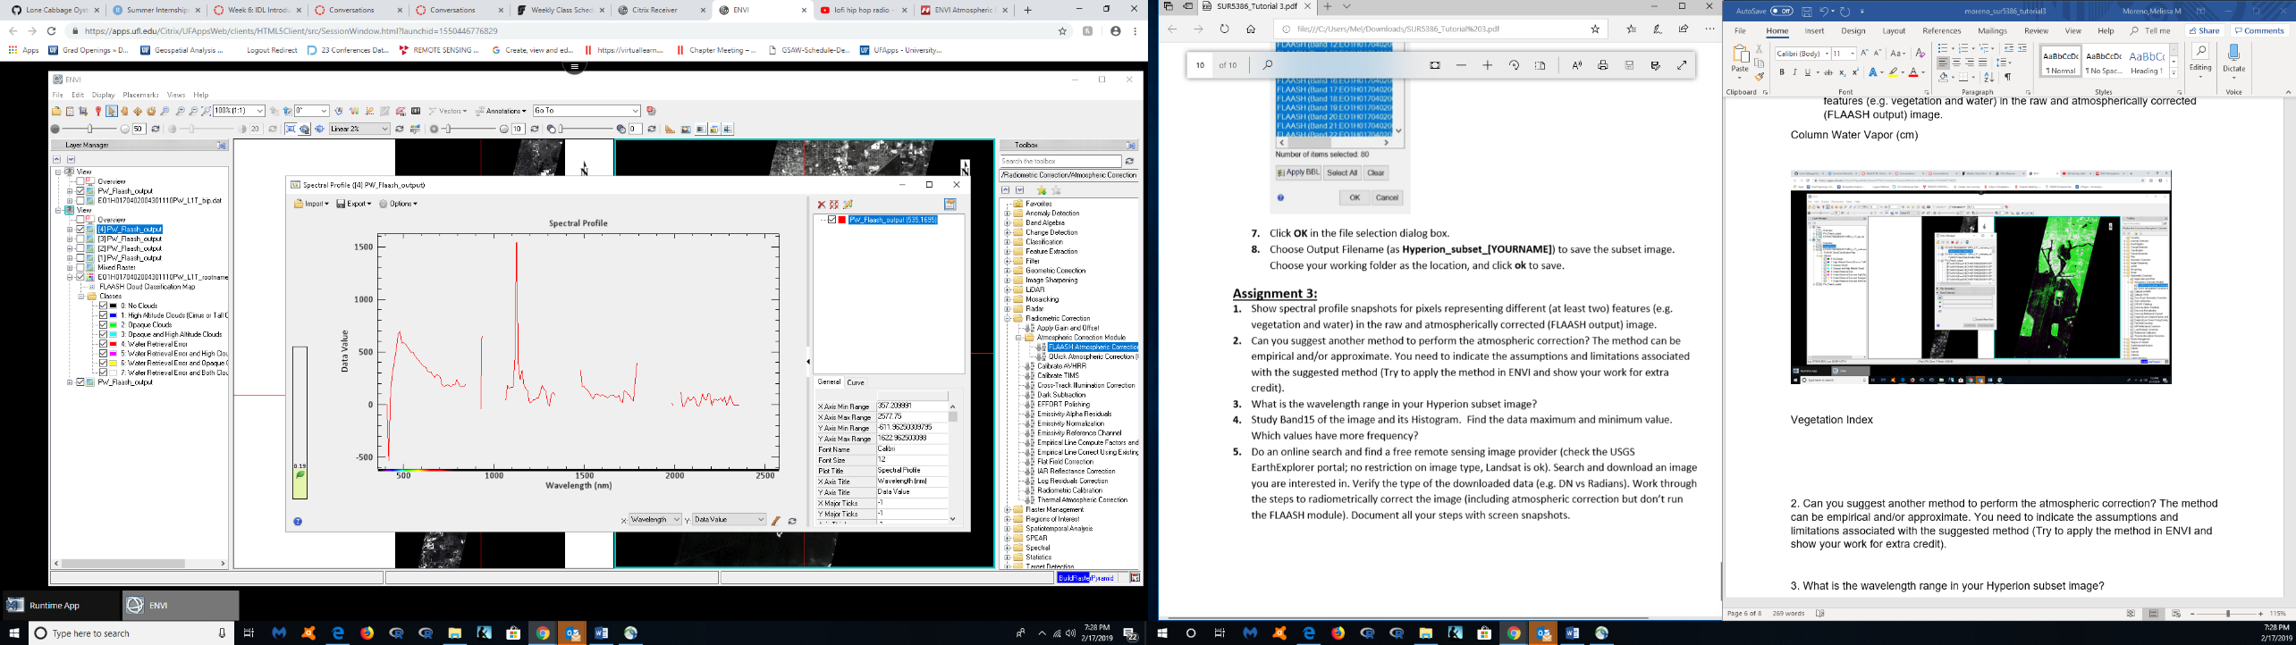Vegetation Index

2. Can you suggest another method to perform the atmospheric correction? The method can be empirical and/or approximate. You need to indicate the assumptions and limitations associated with the suggested method (Try to apply the method in ENVI and show your work for extra credit).

In ENVI 4.8 or ENVI Classic (comes with ENVI 5 and later), you can use the menu: Basic Tools -> Preprocessing -> Calibration utilities -> Empirical Line. However, for this method you do need to have some known reflectance’s in the scene. (<https://www.researchgate.net/post/How_can_I_perform_an_atmospheric_correction_of_hyperion_data>)

Another way to perform an atmospheric correction is ATREM - Atmosphere Removal.

The ATREM software was developed to determine the scaled surface reflectance from hyperspectral imagery from both AVIRIS and HYDICE sensors. The atmospheric scattering used by ATREM is modeled after the MODTRAN 5S code. The ATREM software assumes that the surface is horizontal and has a Lambertian reflectance. If topography is known, then the scaled surface reflectance can be converted into real surface reflectance. (http://www.csr.utexas.edu/projects/rs/hrs/process.html)

3. What is the wavelength range in your Hyperion subset image?

The wavelength range is from 406.46 to 993.17.

4. Study Band15 of the image and its Histogram. Find the data maximum and minimum value. Which values have more frequency?

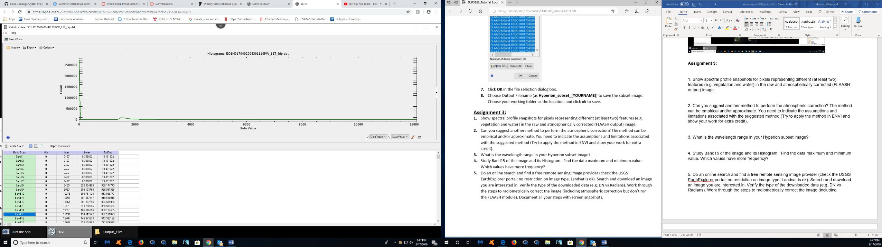

Min- 0

Max- 12131

Mean- 454.31

The values that have the most frequency, or standard deviation, are the bands from 20-50.

5. Do an online search and find a free remote sensing image provider (check the USGS EarthExplorer portal; no restriction on image type, Landsat is ok). Search and download an image you are interested in. Verify the type of the downloaded data (e.g. DN vs Radians). Work through the steps to radiometrically correct the image (including atmospheric correction but don’t run the FLAASH module). Document all your steps with screen snapshots.